# EX.NO:03 07 /02/2025

AIM:

Develop a linear regression model for forecasting time series data

221501019

To develop a linear regression model for forecasting time series data.

# CODE:

import pandas as pd

data = pd.read_csv("Gold_Price_DataSet.csv")

data.head()

data.drop( 'Volume' ,axis=1 ,inplace = True) data.drop( 'Chg%' ,axis=1 ,inplace = True)

data['Date']=pd.to_datetime(data['Date']) data = data.set_index(data['Date'])

import numpy as np

from sklearn.model_selection import train_test_split from sklearn.linear_model import LinearRegression

from sklearn.metrics import mean_squared_error, r2_score

data['Date'] = pd.to_numeric(pd.to_datetime(data['Date']))

X = data[['Date']] y = data['Price']

X_train, X_test, y_train, y_test = train_test_split(X, y, test_size=0.2, random_state=42)

model = LinearRegression() model.fit(X_train, y_train)

y_pred = model.predict(X_test)

mse = mean_squared_error(y_test, y_pred) r2 = r2_score(y_test, y_pred)

print(f"Mean Squared Error: {mse}") print(f"R-squared: {r2}")

## OUTPUT:



import matplotlib.pyplot as plt

# Create the scatter plot plt.figure(figsize=(10, 6))

plt.scatter(X_test, y_test, color='blue', label='Actual')

plt.scatter(X_test, y_pred, color='red', label='Predicted')

# Customize the plot plt.xlabel("Date") plt.ylabel("Price")

plt.title("Actual vs Predicted Gold Prices")

plt.legend() plt.grid(True)

# Show the plot plt.show()

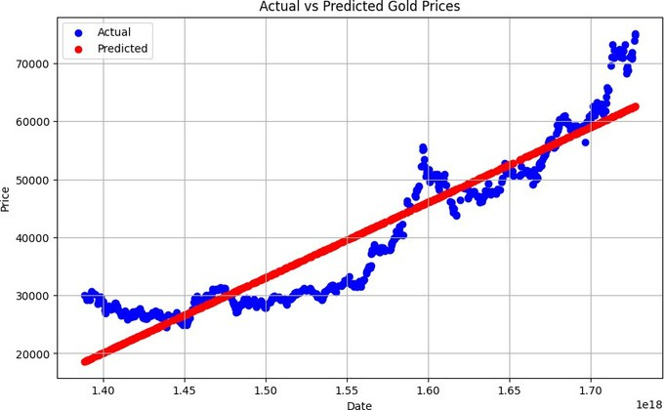

give = pd.DataFrame([pd.to_numeric(pd.to_datetime(['2023-01-01']))]) give.columns = ['Date']

g = model.predict(give) print(g)

# OUTPUT:

[55484.20951941]

## RESULT:

A linear regression model for forecasting time series data has been developed .